1. Download Visual Studio Code
   1. <https://visualstudio.microsoft.com/>
   2. Select your OS from [Download Visual Studio Code] drop down menu
2. Install Visual Studio Code
   1. Installing is simple. Follow the instruction. When you get to this section make sure to check these boxes.

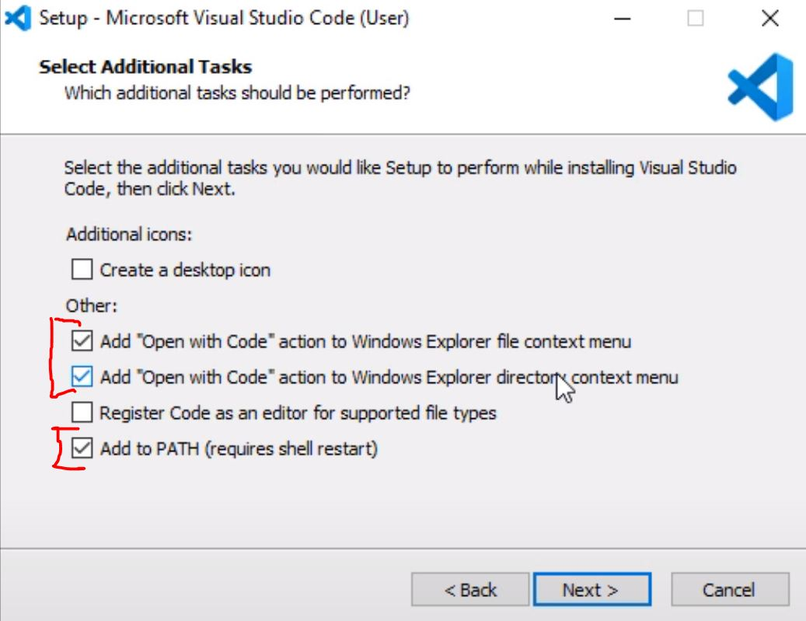

1. Installing helpfull package in VS Code
   1. Open VS Code
   2. **Installing C#**
   3. Click on [ Extensions button ] on the left (see image below)
   4. Type C# in Search bar (see image below)
   5. Click the very first Option (see image below)
   6. Click [ install button ] on the right (see image below)

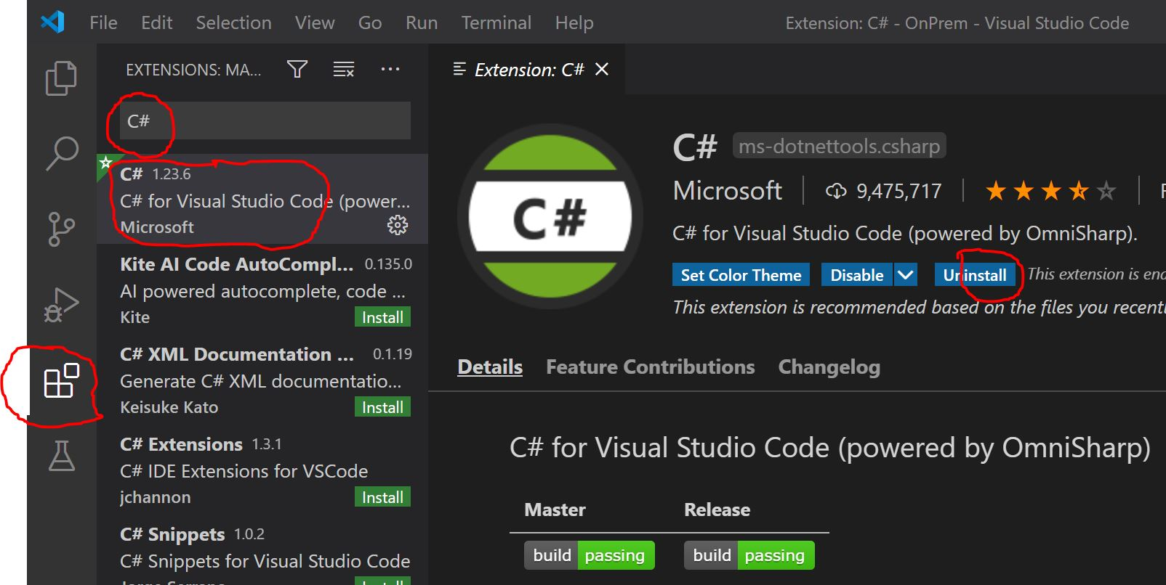

* 1. **Installing Visual Studio IntelliCode**
  2. Click on [Extensions button] on the left
  3. Type Visual Studio in Search bar
  4. Click the very first Option
  5. Click [install button] on the right

1. Checking for [ DOTNET CORE SDK ]
   1. Open Command Prompt
   2. Type [dotnet - -version]
   3. The latest version is **v3.1.404**
   4. If you don’t have the SDK or the latest version, go to <https://dotnet.microsoft.com/download>
   5. Click on [ Download.NET Core SDK x64 ]
   6. Once downloaded install the SDK
2. Creating ASP.NET Core MVC web Application
   1. From you desktop, Open Command Prompt
   2. Type [ dotnet new mvc -n GroceryStore ]
   3. Once completed, Type [ cd GroceryStore ]
   4. Type [ code . ]. This will open VS Code.
   5. You will see window pop up on the bottom right inside VS Code. Click yes. (See image below)

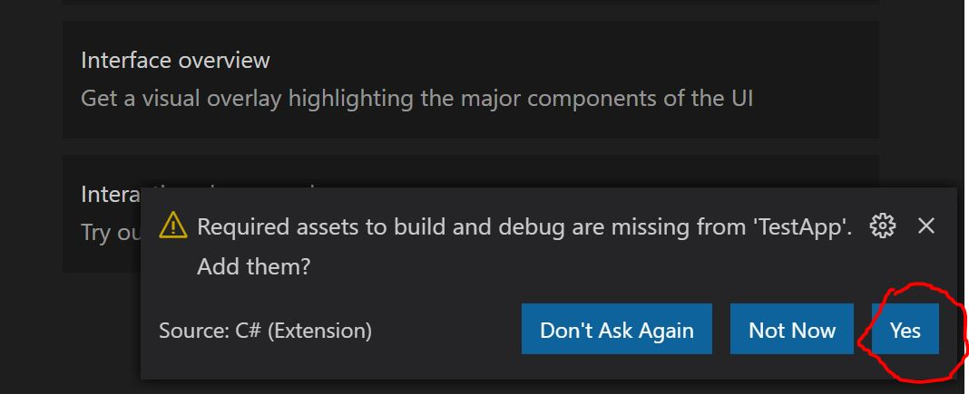

1. Lets check the application
   1. On the top click on [ view > Terminal ]. This should open terminal inside VS Code.
   2. Inside Terminal, Type [ dontnet run ] and press Enter

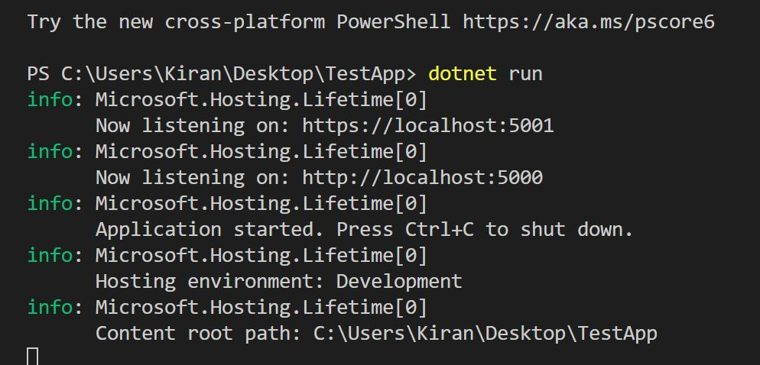

* 1. Open a web browser and in the address bar Type [ localhost:5001 ]
  2. More then likely, it is going to give you an error because 5001 is a secure line and we don’t have certificate created yet.
  3. Click on the [ Advance button ] and click [ continue ]
  4. You should get a web page that looks like this. (see image below)

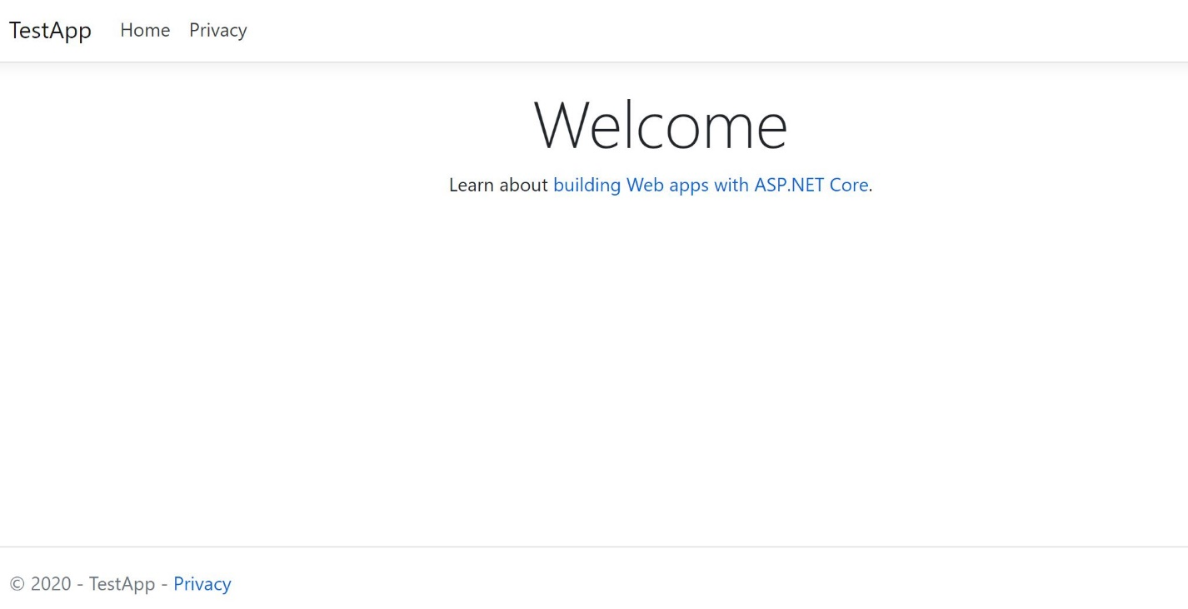

Congratulation! You just created MVC web application using VS Code

* Press Ctrl + C to get out of debug mode.